Prolific is chaos

A guide to approving submissions when you can barely keep track of them
Contents:
- General
- Walkthrough – the most efficient way to approve prolific submissions
- Templates – what to say when. Don’t waste time thinking up a message; just take one of these.

General Tips
- Prolific is a great platform but we don’t want to be boycotted by these people! Remember to be as polite and neutral as possible in your dealings with them, even if they are unreasonable. Use the templates below to familiarize yourself with the “polite” tone.
- If they raise an issue with the study, politely ask them to return it.

Walkthrough
- Download qualtrics data and task data and compile a new, cleaned dataset consisting only of the submissions that you want to keep
- Write these ids to a text file, separated by commas. Click on “Approve by upload” and paste these ids into the text box.
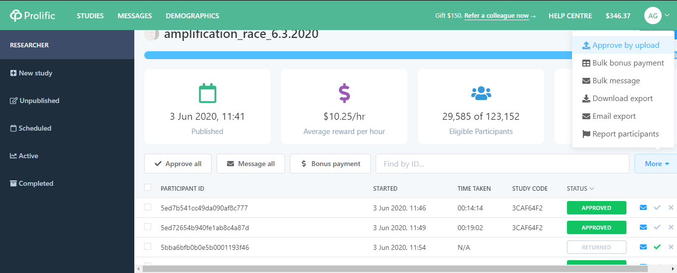
- This will auto-approve all people who have completed the study.
- Reject any participants with NOCODE in the STUDY CODE column.

Templates

If they raise a technical issue:
Hello,
Thank you for bringing this to our attention! We will try to fix this. Please return the study to prolific. Best wishes and we thank you again for participating.

If they accidentally inserted the wrong ID:

Dear participant,

Some individuals accidentally wrote their MTURK id instead of their prolific ID and we cannot credit them for their work as a result. If you have an MTURK id, please reply with the last two characters of it in order for us to confirm your identity and credit you for your study.
Thanks!

If they contest a rejection (unreasonably):
Dear participant,
Your study was rejected for [X] reasons. [Insert stuff here].
Thanks for reaching out. Please let us know if you have any more questions.
Sample:
Dear participant,
Your study was rejected for three reasons [(1) because you failed to provide the correct completion code, (2) because there is no data associated with your prolific id, (3) because the average amount of time spent on this study is 10-12 minutes, whereas prolific indicates that you spent less than 2 minutes].
Thanks for reaching out. Please let us know if you have any more questions.

